DEPARTMENT OF VETERANS AFFAIRS
VA Regional Office
«ROAddress»

«CurrentDate»

«FullName» | In Reply Refer to:
«MailingAddress» | «ROStationNumber»/28  «ClaimPayee»

Dear «LastName»:

Your application for Chapter 31 benefits has been processed. I am writing to inform you of a decision that affects your Department of Veterans Affairs (VA) Veteran Readiness and Employment (VR&E) benefits. This decision does not impact other VA benefits that you may be receiving and/or be eligible to receive.

What was the decision and what authority was used?

You have been determined eligible to receive an initial evaluation to determine if you are entitled to Chapter 31 benefits. This decision is based on 38 U.S.C.§ 3103 and 38 CFR § 21.40. Therefore, you have been scheduled for an initial evaluation appointment with a VA Vocational Rehabilitation Counselor (VRC), which is provided in this letter.

How was the decision made?

You met the eligibility criteria to participate in an evaluation to determine your entitlement to Chapter 31 benefits based on 38 CFR § 21.40.

What findings were favorable to you, if any?

You have been scheduled for an initial evaluation appointment with a VA VRC. During this meeting, the VRC will gather information to determine if you meet the criteria for entitlement to Chapter 31 benefits.

What evidence did I use to make this decision?

The decision was made based on the VA rating decision for your service-connected disability(ies).

What if you disagree with my decision?

If you do not agree with the decision, you have one year from the date of this letter to select a review option to preserve your earliest effective benefit date.

Please review the enclosed VA Form 20-0998, Your Rights to Seek Further Review of Our Decision, which provides instructions on your options for an additional review.

The review options and corresponding applications are listed below:

- Supplemental Claim (SC), complete VA Form 20-0995, Decision Review Request: Supplemental Claim (Completed form may be submitted to the VR&E Intake Center below.)

- Higher-Level Review (HLR), complete VA Form 20-0996, Decision Review Request: Higher-Level Review (Completed form may be submitted to the VR&E Intake Center below.)

- Appeal to the Board, complete VA Form 10182, Decision Review Request: Board Appeal (Notice of Disagreement)

You may obtain any of the required forms by downloading them from https://www.va.gov/find-forms/ or by contacting me. You can also learn more about the disagreement process at http://www.va.gov/decision-reviews.

If you would like to obtain or access evidence used in making this decision, please contact us as noted below. Some evidence may be obtained by signing in at www.va.gov.

Note: You may elect either an HLR, a SC review, or an appeal to the Board. You may not have the same issue under HRL, SC review, or an appeal to the Board at the same time. You must elect which option you wish to pursue.

What is the next step?

You need to report on time for your scheduled Tele-Counseling appointment as shown below:

Date: |  | «AppointmentDate»
Time: |  | «AppointmentTime»
Place: |  | «AppointmentPlace»
You may request to report to the office for your initial evaluation, if you prefer, by calling me at (insert telephone number).

What do you need to prepare before the meeting?

- Complete, sign, and submit the following items at least one business day prior to the virtual appointment via Tele-counseling or bring to your in-person meeting:

- VAF 28-1902w, Veteran Readiness and Employment Questionnaire and VAF 28-0800, VR&E Program Orientation. These forms are enclosed with this letter and are also available online at https://www.va.gov/find-forms/, where they can be completed online, printed, and sent to the address provided at the end of this letter, via direct upload, or via email.
- Training records including military training, college or university transcripts, vocational training records.
- Resume(s).
- Job certifications or licenses, such as an apprentice or journeyman rating card.
- Recent medical records that may not be available to VA.

- Part of your initial evaluation is a career assessment. (Select one below)

- You may complete the assessment located at (insert career assessment website) prior to your scheduled meeting by taking the following actions:

- Enter the above URL in the web browser address bar. Log in and register using the information below
- Use the following for username and password:
- User ID: First.Last name Example: John.Doe (put a period between the first and last name).
- Password: Last name and last 4 of your social security number, Example: Doe1234 (do not put a space between the last name and number).

[If not using CareerScope, remove directions and insert local assessment information below.]

- You will be provided career assessment on the day you report for your scheduled initial evaluation.

What to expect during your scheduled appointment?

- Virtual Appointment via Tele-counseling:

Tele-counseling uses the VA Video Connect application, which is accessible on any web-enabled device, such as a smartphone, tablet, or a laptop computer, with a webcam and microphone. You will need to download the free application and click on the Tele-counseling link to start the meeting. You may contact the National Telehealth Technology Helpdesk (NTTHD) at 855-519-7116, Monday – Saturday, 7am – 11pm (ET) for technical difficulties or additional technical support.

View the orientation video at https://www.youtube.com/watch?v=49eWvGitLPw.

Items listed in #1 above must be completed, signed, and returned with any of the other items listed above at least one business day prior to your scheduled appointment, you may use one of the following methods:
- Direct Upload – The instructions for sending documents are provided in the attached document, Instructions for Document Upload Via Direct Upload and Encrypted Email.
- Email – Send the completed documents at [insert email address].

The information requested above assists in determining entitlement to benefits and services under VR&E. Failure to provide the requested information as outlined above may result in not receiving the maximum benefits or may result in not receiving VR&E benefits for which you have applied, as outlined in Protection of Privacy Statement in VAF 28-1902w.

Note: During the Tele-counseling session, you must be in a private setting to ensure confidentiality of your personal information and to avoid any distractions. If you wish to have anyone present during your appointment, you must sign a release of information before the person may attend your Tele-counseling session. The setting must also provide sufficient lighting and noise control. If you are driving or a passenger in an automobile during the scheduled Tele-counseling session, it will be immediately cancelled or rescheduled.

VA considers a Tele-counseling appointment the same as an in-person meeting. This means that you are expected to attend the meeting on time, be professionally dressed, and be prepared to discuss a detailed history of your past and current military, work, and education background.

Any activities outside a professional meeting, such as driving, eating, exercising, walking, etc., during the Tele-counseling session are not permitted. The session will be immediately cancelled and will be rescheduled if this occurs.

- If your appointment is in-person at a specified location:

- Plan for the meeting to last two hours or more as the meeting may also involve a career assessment.
- Do not bring unaccompanied minor children with you.
- Bring the information outlined in Item #1 above.

Even if you do not meet the entitlement criteria for Chapter 31, you will still be provided career and educational counseling at no expense to you, which is a substantial benefit by itself.

What will happen during the meeting?

We will discuss all the information that may help us make decisions on your request for vocational rehabilitation services, which may include the following:
- Your work history, job interests, past training, and education
- Your disabilities and how they affect your everyday life
- Any other questions you may want answered
- Whether you are entitled to receive Chapter 31 benefits

What other criteria must you meet to be entitled to Chapter 31 benefits?

If your combined service-connected disability rating awarded by VA is 10%, or it has been more than 12 years since you were discharged from active-duty status, we must be able to determine the following:
- You have major difficulties obtaining or maintaining a job that matches your talents, skills, and interests, and
- Your service-connected disability condition(s) is/are a substantial part of the reason you have difficulties obtaining and maintaining a job.

Note: If you were discharged or released from active military service on or after January 1, 2013, the 12-year eligibility period does not apply to you.

What if you previously successfully completed a Chapter 31 program?

To receive additional services after you have been rehabilitated, you must meet the basic eligibility and entitlement criteria, and a VRC must determine that you need additional services. We must also determine that you meet one of the following conditions:
- Your service-connected disability has worsened that you can no longer perform the duties of the occupation for which you were found rehabilitated
- The occupation for which you were determined rehabilitated is no longer suitable based on your specific employment handicap and capabilities
- If you received a plan of Independent Living services, either your conditions have worsened and you need additional services or your conditions have improved and you now need assistance to pursue employment
- If you were determined rehabilitated because you pursued additional training instead of receiving employment services at the time and you now need assistance to find suitable employment

You should submit any evidence indicating you need further vocational rehabilitation services, such as medical information, a doctor’s statement, or a recent notice of an increase in your VA disability rating. Your assigned VRC will assist you in identifying the needed additional information.

Who will pay you travel expenses?

If you must travel to your appointment, we will pay the cost of your travel based on the following:
- Public transportation costs
- If public transportation is not available, the current mileage rate for the round trip, plus parking, ferry fares and bridge, road, and tunnel toll fees, as applicable

You must submit actual receipts with your travel reimbursement request, which must be made within 30 days after completing your trip.

What are the next steps?

- If you are determined entitled for Chapter 31 benefits, we will begin your vocational planning immediately.
- If you are not determined entitled, you will be referred to other agencies for assistance.

What if you have questions or concerns?

If you have any questions about this letter or need additional information on VA benefits, please contact me at «CaseMgrPhone», via email at «CaseMgrEmailAddress», or call 1-800-827-1000. If you use the Telecommunications Device for the Deaf (TDD), the federal number is 711.

You may also contact me by mail at:

Veteran Readiness and Employment (VR&E) Intake Center
Department of Veterans Affairs
P. O. Box 5210
Janesville, WI 53547-5210

Sincerely yours,

«CaseMgrName»
«CaseMgrTitle»

Enclosures:
Instructions for Document Upload via Direct Upload and Encrypted Email
VAF 20-0998
VAF 28-1902w
VAF 28-0800

cc: «POAName»

VR-03 Rev March 2023

INSTRUCTIONS FOR DOCUMENT UPLOAD
VIA DIRECT UPLOAD AND ENCRYPTED EMAIL

DIRECT UPLOAD

A secure website is available for uploading completed documents for your Chapter 31 initial evaluation.

Access the website at https://eauth.va.gov/accessva/ and use the ID.me credentials.
Follow the instructions provided in the website.

Select Veteran Readiness and Employment to ensure that the documents are sent to the appropriate VR&E office.

ENCRYPTED EMAIL

- Compose a new email.

- Click on the “Options” tab.

- Click the drop down arrow on the “Permission” button and select “Encrypt-Only” as shown below:

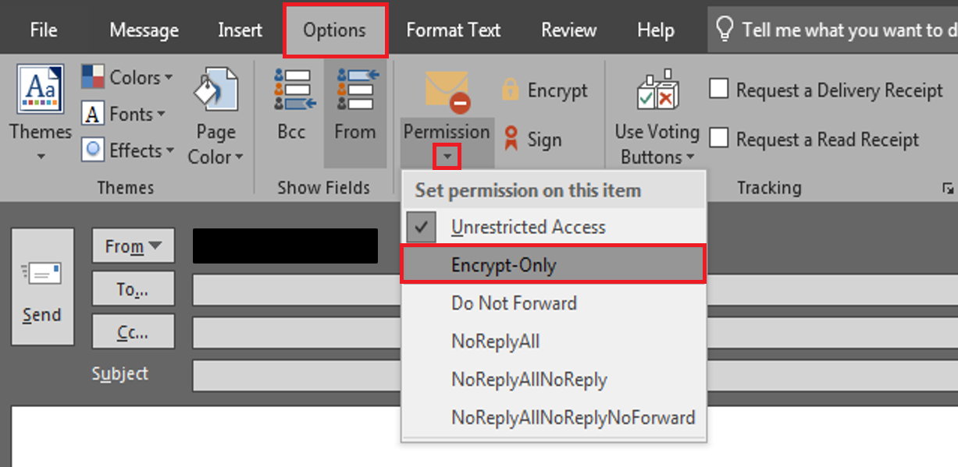

- The message below will appear above the “From” line indicating that the email will be sent securely.
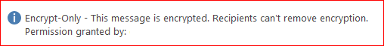

- Send email.

VAF 20-0998, YOUR RIGHTS TO SEEK FURTHER REVIEW OF OUR DECISION

YOUR RIGHT TO SEEK REVIEW OF OUR DECISION
This document outlines your right to seek review of our decision on any issue with which you disagree. You may generally select one of three different review options for each issue decided by VA. However, you may not request review of the same issue using more than one option at the same time. Below is information on the three different review options.

Supplemental Claim Higher-Level Review Board Appeal

What Is This?
A reviewer will determine whether new and relevant evidence changes the prior decision.
An experienced claims adjudicator will review your decision using the same evidence VA considered in the prior decision.
A Veterans Law Judge at the Board of Veterans' Appeals (Board) will review your decision.

By Selecting This Option

You are adding or identifying new and relevant evidence to support your claim that we did not previously consider.

VA will assist you in gathering new and relevant evidence that you identify to support your claim.

You have no additional evidence to submit to support your claim, but you believe there was an error in the prior decision.

You can request an optional, one-time, informal conference with a Higher-Level Reviewer to identify specific errors in the case, although requesting this conference may delay the review.

You must choose a docket:
Direct Review - You do not want to submit evidence or have a hearing.
Evidence Submission - You choose to submit additional evidence without a hearing.
Hearing - You choose to have a hearing with a Veterans Law Judge.

Goal to

Complete

125 days on average 125 days on average

365 days on average for
Direct Review (longer for the other options)

Form To File To Select This Option*

Further Options After This Decision Review

VA Form 20-0995,
Decision Review Request: Supplemental Claim

You may request another Supplemental Claim, a Higher-Level Review, or a Board Appeal.

VA Form 20-0996,
Decision Review Request: Higher-Level Review

You may request a Supplemental Claim or a Board Appeal.

VA Form 10182,
Decision Review Request: Board Appeal (Notice of Disagreement)

You may request a Supplemental Claim or appeal to the U.S. Court of Appeals for Veterans Claims.

* All forms listed above are available at www.va.gov/vaforms/.
For most VA benefits, you have 1 year from the date on your decision notice to request a decision review to ensure the earliest possible effective date. Consult your decision notice for specific limitations.

If you do not submit a decision review request within the required time, you may only seek review through the following:
- A request to revise the decision based on a clear and unmistakable error, or
- A Supplemental Claim. If you file a Supplemental Claim after the 1-year time limit, the effective date for any resulting award of benefits generally will be tied to the date VA receives the Supplemental Claim.

While most decision review options are available to you, there are limitations based on the type of decision you received.
- If you are a party to a contested claim - such as claims for apportionment, attorney fee disagreement, or multiple parties filing for survivor's benefits - your only option for disagreeing with your decision is to file a Board Appeal within 60 days of the date on your decision notice.
- If you are seeking review of an insurance decision you have an additional option to challenge VA's decision by filing a complaint with a United States district court in the jurisdiction in which you reside within 6 years from when the right of action first accrues. Consult your decision notice for details on what options are available and where to send the request.

Get Help with Your Review Request:

For more information on all the available review options, contact us at 1-800-827-1000 or visit www.va.gov/decision- reviews/. If you need help filing a decision review, you may want to work with an accredited attorney, claims agent, or a Veterans Service Organization (VSO) representative. Additional information about working with an accredited attorney, claims agent, or VSO representative is available at www.va.gov/decision-reviews/get-help-with-review-request/. You may also find a directory of accredited representatives at www.va.gov/vso.

VAF Form 20-0998 SUPERSEDES VA FORM 20-0998, JAN 2019 Page 1
FEB 2021

